Solution Design

Tata Play Fiber Self-Onboarding Middleware Backend

Solution Design Document (SDD)
This document describes the high-level solution design and business workflow for the Tata Play Fiber Self-Onboarding Middleware Backend. The middleware acts as a centralized service orchestrating the onboarding journey for customers across third-party client applications.
For low-level technical specifications, database schemas, API JSON payload contracts, and Spring Boot component codes, refer to the Low-Level Design (LLD).
---

1. High-Level System Architecture
The middleware exposes secure endpoints for frontend applications (web portals, mobile apps, kiosks) and integrates with core internal and external services.
--- Flowchart/Sequence Diagram 1 ---
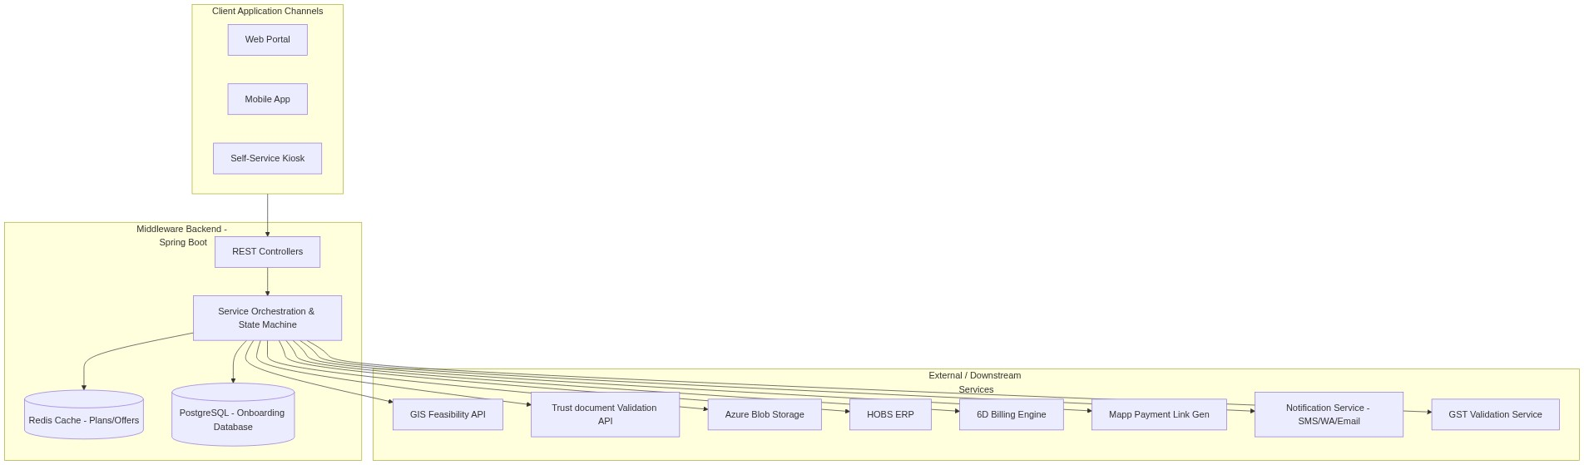

Editable Flow Chart / Message Sequence Table (Edit Directly inside MS Word):
No. | Trigger / Component | Target / Integration | Action Description | Execution Type | Exception Handling
1 | 3rd Party UI | Middleware API | POST /payment-link | Synchronous | Standard validation error return.
2 | Middleware API | HOBS ERP | Create Customer & Billing Account | Synchronous | Halt & fail request if HOBS is offline.
3 | Middleware API | PostgreSQL DB | Update master table to HOBS_CREATED | Synchronous | Saves database state.
4 | Middleware API | 3rd Party UI | Return HTTP 202 Accepted & Account IDs | Synchronous | Provides immediate response.
5 | Middleware API | 6D Billing Engine | Poll billing sync status (3 retries with 5s backoff) | Asynchronous | Log sync fail and trigger email alert to retry.
6 | Middleware API | Mapp API | POST /payment/link (Generate payment link) | Asynchronous | Lock progress and log failure.
7 | Middleware API | PostgreSQL DB | Save payment link, amount, and expiry | Asynchronous | Updates payment record.
8 | Middleware API | Notification Service | Trigger SMS, WA, Email with payment link | Asynchronous | Dispatches link to customer.

---

2. Onboarding Workflow & State Machine
The onboarding journey is governed by a strict step-by-step flow. Customers must complete each step successfully before being allowed to proceed to the next stage. If they leave the portal and return later, they are automatically restored to their last successful step.
--- Flowchart/Sequence Diagram 2 ---
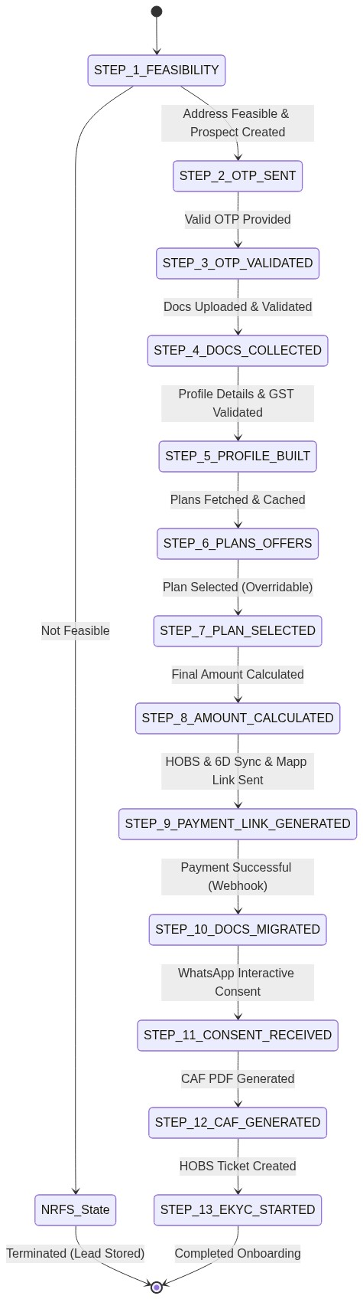

Editable Flow Chart / Message Sequence Table (Edit Directly inside MS Word):
Step | Onboarding Gate / Phase | Key Business Process & Systems | Next Transition Criteria
Step 1 | Feasibility Check | Capture personal details and call GIS feasibility API. | If Feasible: Create Prospect ID and store lead. Proceed to Step 2. If NRFS: Set status and halt.
Step 2 | OTP Dispatch | Generate a 6-digit OTP code and send it to the registered contact details. | OTP sent successfully -> Proceed to Step 3.
Step 3 | OTP Validation & Recovery | Check OTP and determine if customer is new or returning. | If New: Redirect to Step 4. If Returning: Retrieve previous step and redirect.
Step 4 | Document Collection | Upload POA/POI files to Azure Blob Storage and call Trust APIs to perform OCR & facial recognition. | If Trust validation passes -> Proceed to Step 5. If fails -> Lock flow and halt.
Step 5 | Profile Building | Capture additional profile properties and validate GST registration details. | GST validated or skipped -> Proceed to Step 6.
Step 6 | Plans & Offers Consolidation | Fetch packages based on city (Redis cache) and merge with Magix coupons. | Plans consolidated -> Proceed to Step 7.
Step 7 | Plan Selection | User selects a package. This configuration remains overridable until payment. | Plan selected -> Proceed to Step 8.
Step 8 | Amount Calculation | Generate final invoice amount with taxes (GST) and discounts. | Invoice generated -> Proceed to Step 9.
Step 9 | Payment & Account Orchestration | Create account in HOBS (Sync). Wait for 6D Billing sync (Async). Generate payment link via Mapp. | Payment link generated -> Dispatched to customer. Proceed to Step 10.
Step 10 | Document Migration | Triggered by payment success. Copy files from leads folder to customer ID folder in Azure. | Files copied successfully -> Proceed to Step 11.
Step 11 | WhatsApp Consent | Dispatch interactive consent request on WhatsApp. Receive response via webhook. | Consent approved -> Proceed to Step 12. If declined -> Halt.
Step 12 | CAF PDF Generation | Compile customer details, selected plan, and consent log into a PDF CAF in Azure. | CAF generated -> Proceed to Step 13.
Step 13 | EKYC Process Initiation | Create a service ticket in HOBS system to kick off the final EKYC verification. | Ticket created -> Complete onboarding flow.

---

3. High-Level Step Descriptions

Step 1: Capture Lead & GIS Feasibility Check
- **Business Goal**: Validate if the customer's physical location is feasible for fiber provisioning.
- **Process**: Capture name, contact details, email, and coordinates. Call the GIS Feasibility API.
- **If Feasible**: A unique `prospect_id` is created, lead details are stored as active, and the flow moves to Step 2.
- **If Not Feasible**: Lead details are stored with status `NRFS` (Not Ready For Service) to allow future follow-ups, and the client application is notified to display a feasibility error.

Step 2: Send OTP
- **Business Goal**: Verify customer contact information before collecting sensitive documents.
- **Process**: Generate a secure verification code and send it to the customer's registered mobile number (RMN) and email address.

Step 3: Validate OTP & State Recovery
- **Business Goal**: Authenticate the customer and retrieve their previous session state.
- **Process**: Check the user-entered OTP.
- **New Customers**: Directed to start at Step 4 (Document Collection).
- **Returning Customers**: The middleware checks the master tracking record and resumes their session, returning the data and redirecting them to the exact step where they previously stopped (e.g., Plan Selection or Payment).

Step 4: Document Collection & Validation
- **Business Goal**: Gather identification and address proof, and verify authenticity.
- **Process**:
- Upload Proof of Identity (POI), Proof of Address (POA), and a live photo to Azure Blob Storage (retaining file paths and metadata only in the database).
- A declaration form is auto-generated in PDF format and saved with the files.
- Call verification APIs to perform OCR validation and facial matching. If successful, progress to Step 5 is unlocked.

Step 5: Profile Building
- **Business Goal**: Complete customer billing details and business info.
- **Process**: Capture customer demographic and GST details. Validate GST registrations against national portals.

Step 6: Plans & Offers Consolidation
- **Business Goal**: Present available fiber packages and active offers.
- **Process**: Retrieve packages based on the customer's city (cached in Redis to ensure low latency) and merge them with active promotional coupons/offers fetched from the Magix API.

Step 7: Plan Selection (Overridable)
- **Business Goal**: Record the customer's selected fiber plan.
- **Process**: Persist package and discount choices. The customer can go back and re-select or override their selection at any time before payment.

Step 8: Calculate Amount
- **Business Goal**: Display a clear pricing breakdown to the customer.
- **Process**: Compute base prices, apply promotional discounts, calculate local taxes (GST), and return the final invoice amount.

Step 9: Payment Link Generation & Provisioning Orchestration
- **Business Goal**: Create customer accounts in core systems and provide a payment route.
- **Process**:
- Synchronously create the customer account and billing account inside the HOBS ERP.
- Asynchronously poll the 6D Billing Engine to verify synchronization.
- Once synced, invoke the Mapp API to generate a single-use payment link and send it via SMS, email, and WhatsApp.
- **Regeneration Logic**: If the link expires or the request is retried, the middleware checks HOBS/6D creation. If not created, it retries provisioning; otherwise, it sends the existing unexpired link or generates a fresh one.

Step 10: Document Migration
- **Business Goal**: Transition documents from lead storage to permanent customer storage.
- **Process**: Upon receiving a payment success notification (via webhook), documents are automatically copied from the prospect folder to the permanent customer ID folder in Azure Blob Storage.

Step 11: Customer WhatsApp Consent
- **Business Goal**: Gather statutory electronic consent.
- **Process**: Send a template message to the customer's WhatsApp. The customer grants consent directly via WhatsApp interactive buttons, which triggers a webhook to update the onboarding record.

Step 12: CAF Generation
- **Business Goal**: Finalize the Customer Application Form.
- **Process**: Generate the final CAF document as a PDF containing all validated details, photo, and consent logs, and upload it to the customer ID folder.

Step 13: EKYC Start
- **Business Goal**: Initiate the final validation ticket.
- **Process**: Create a service ticket in HOBS to notify field/logical verification teams to start the EKYC process, concluding the onboarding cycle.
---

4. Key Business Controls

State Gatekeeper (Sequential Verification)
A core component ensures customers cannot jump steps or access endpoints ahead of their current authorized stage. Each request verifies the prospect's stage in the database. Out-of-order calls are immediately rejected, returning instructions to return to the active stage.

Document Access Security
No document files are accessible via public links. The middleware serves documents via temporary, secure Shared Access Signature (SAS) tokens with a 10-minute expiry time to prevent unauthorized access.

Status Tracking & Retrieval API
A unified endpoint retrieves the current milestone and status details using either the prospect ID, customer ID, or registered mobile number (RMN).

